**CSE 115 – Introduction to Software Engineering**

**Sprint PlanTemplate**

The team needs to capture the result of their sprint planning meeting in a document with the structure outlined below. This document (as well as other project documents should be made accessible to the team’s TA (e.g., via shared Google docs or drive).

There is no further submission process. All project documents are created for the benefit of

your project and team, not the entertainment of the teaching staff.

**Heading:** Document name ("Sprint {number} Plan"), product name, team name, sprint

∙

completion date, revision number & revision date.

* Product Name: FeelWell
* Product Name: Team Name: FeelWell Team
* Sprint Completion Date: Jul 6, 2024
* Revision Number: 0
* Revision Date: Jun 30, 2024

**Goal:** Short, 1-2 sentence description of the high-level goal(s) for the sprint.

Having the infrastructure and features to host a minimum viable product. Login and create account, access homescreen,

∙

**Task listing, organized by user story:** This section lists the user stories, in priority order from

∙

most important (top) to least important (bottom). Within each user story, there needs to be a list of tasks required to implement the user story, along with the time estimate for each tasks (preferably less than or equal to 6 ideal hours). This should look like:

*User story 1 ("As a {user role}, I want {goal} [so that {reason}]")*

*Task 1 description (time estimate for task 1)*

*Task 2 description (time estimate for task 2)*

*...*

*Task N description (time estimate for task N of user story 1)*

*Total for user story 1: XX hours*

*User story 2*

*Task 1 description (time estimate for task 1)*

*Task 2 description (time estimate for task 2)*

*...*

*Task N description (time estimate for task N of user story 2)*

*Total for user story 2: YY hours*

*...*

*User story M*

*Task 1 description (time estimate for task 1)*

*Task 2 description (time estimate for task 2)*

*...*

*Task N description (time estimate for task N of user story M)*

*Total for user story M: ZZ hours*

* {1}As a player, I want to be able to log in to my account in order to save my progress. [13]
  + Login screen (3-4 Hours)
  + Working with Database (5-6 Hours)
  + Setting Up Web Server (2-3 Hours)
* {1.5} As a player I want to be able to access each feature in a homescreen [2]
  + User Interface (2-3 Hours)
* {2}As a player, I want to be able to insert tasks within my schedule to gamify my habits within my weekly schedule [5]
  + User Interface (2-3 Hours)
  + Saving Progress (2-3 Hours)
  + Making the Interactable Schedule (5-6 Hours)
* {2.5} As a player, I want to be able to access each feature even when I am offline
  + Progressive Web App (3-5 Hours)
  + Database Syncing (4-5 Hours)
* {3}As a player, I want to have daily/weekly “quests” that I can work towards if I choose to. [2]
  + User Interface (2-3 Hours)
  + Gameplay (2-3 Hours)

**Team roles:** Give a listing of all team members. Next to the team member, list their role(s) for

∙

this sprint. Assign each person to at least one role (for example, this role might be "Developer"). This looks like:

*Aidan (developer)*

*Erick (developer)*

*Harry (Developer/Product Owner)*

*Kevin (developer/Scrum Master)*

*Julian (developer)*

∙ **Initial task assignment:** A listing of each team member, with their first user story and task assignment. This should look like:

*Aidan: {3} Daily/weekly “quests”, User Interface*

*Erick: {2.5} Progressive Web App (Offline app), database syncing*

*Harry: {1} Log-in, Working With Database*

*Kevin: {2} User Interface*

*Julian {1.5} Homescreen, user interface*

∙ **Initial burnup chart:** A graph giving the initial burnup chart for this sprint and is labeled as such

with sprint number and project name and is located in the lab.

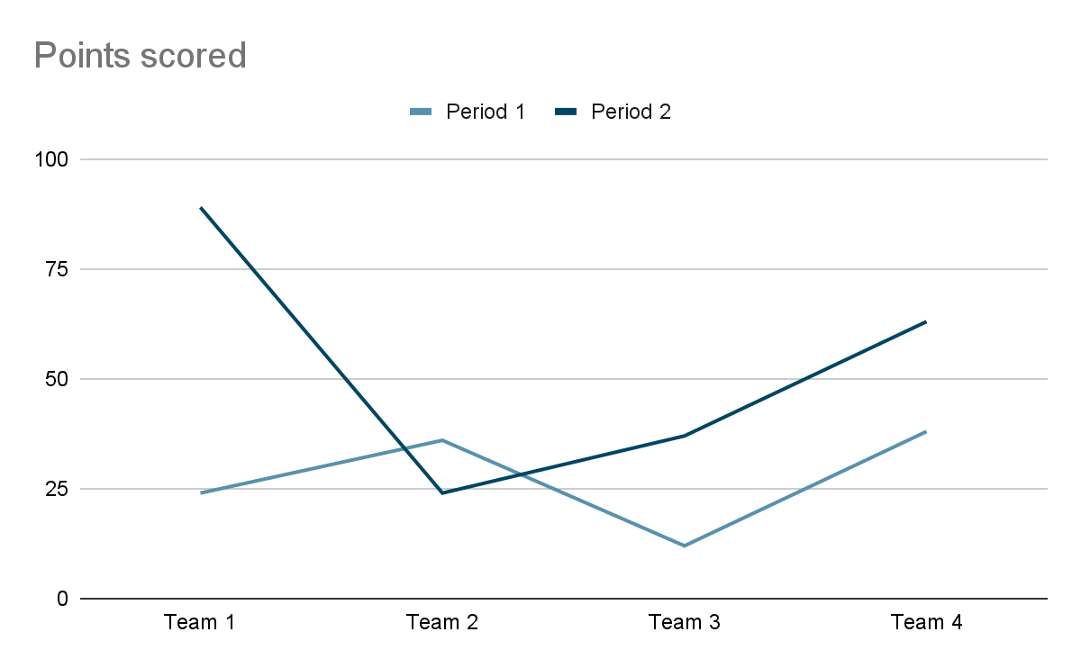

∙ **Initial scrum board:** Also known as a task board, the scrum board is a physical board and labeled as such with sprint number and project name and located in the lab. This board has four columns, titled user stories, tasks not started, tasks in progress, and tasks completed. Index cards or post-it notes representing the user stories and the tasks for this sprint should be placed in the user stories, tasks not started, and tasks in progress columns. Tasks associated with a user story should be placed in the same row as the user story.

∙ **Scrum times:** List at least the three days and times during the week when your team will meet and conduct Scrum meetings. Also, indicate which of these meetings will have the TA/tutor visit as arranged with the TA/tutor. It is expected the TA/tutor will visit during the Scrum meeting during your lab time.

* Our team plans to meet every Wednesday (3:30-3:40), Thursday (4:45-4:55), and Sunday (3:30-3:40).
* The TA/tutor will visit during our Thursday meeting (4:00 - 4:45).

Note that if the team ended up modifying its release plan during sprint planning, submit an updated release plan document also with the sprint plan.